Villa Gottlieb
Locality Pisa area
Guests 10+2
Bedrooms 5 double bedrooms+ 2 extra beds to add
Bathroom 5 en-suite
Heatable pool
Pet friendly on request

Overview
Villa Gottlieb holiday villa with a pool near Pisa is an enchanting stone farmhouse on the hills of Guardistallo town. It has been renewed with care and attention between 2010 and 2011 adopting Tuscan traditions.

Details
Inside Ground Floor: Living room with fireplaces, TV Room, 1 Bathroom First Floor: 5 Double room with ensuite bathroom The holiday villa with a pool near Pisa consists of two levels, on the ground floor there is the entrance towards the lounge decorated with arches, …the old stable, and the large open kitchen nice and charming is separated by a unique open fireplace. The television room with a tiled log stove completes the ground floor. The first floor can be accessed from the kitchen and TV room. The first floor has 5 bedrooms with an en suite bathroom, air conditioning, mosquito nets, and central heating…The outside is always the best a shaded porch with table and chairs, brick bbq, and of course a wonderful swimming pool 10 x 5 meters with two vanishing edges and a uniform depth of 145 cm

Equipment
Washing Machine, Vacuum Cleaner, Dishwasher, Oven, Microwave, Food Processor, Espresso Machine, Coffee Perculator, Toaster, Fridge, Flat Screen TV, Mini Stereo, DVD Player, Swimming pool, Garden Furniture, Deckchairs and Sunbeds, Barbecue, Outdoor shower SKY TV, Internet WiFi.

The prices include
Quote for gas + electricity: 5% of the total rental rate. Over this amount, the cost per kw/h will be calculated based on the market price at that moment.
WI-FI
Linen and bath towels for 1 week

Extra cost

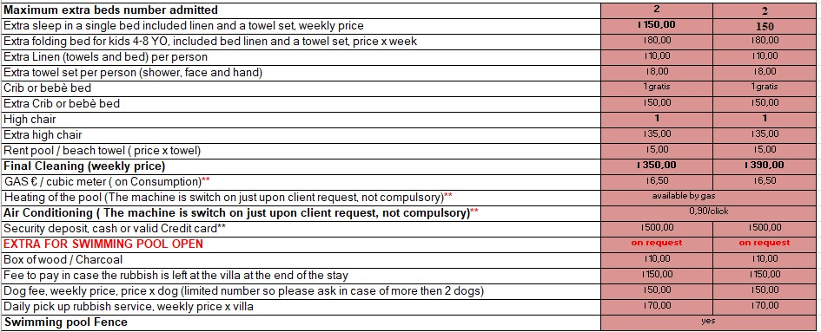

Good to know
Security deposit, EURO cash or Credit Card € 600,00 (A different amount could be asked in case of a long holiday or in other particular cases established by the property)
WATER CONSUMPTION: In case of water problems in the area a limit of water consumption considered included could be fixed. Over this limit, the consumption will be an extra cost to be paid at the end of the holiday period at the price of 5,00 €/m3. We will calculate a sufficient amount of water to cover normal consumption for a normal holiday stay. This is to avoid water wastage.
CLEANING: the final period cleaning is compulsory. In case of stays longer than 1 week the other cleanings are not compulsory but upon request.
SWIMMING POOL: swimming pool is closed in the mid-low season. It could be sometimes opened and an extra fee will be asked. Preventive just upon request. The eventual heating is always extra and switched on upon request. It’s necessary a notice at least 3 weeks prior to the arrival date to open or to heat the swimming pools. Services are not available for last-minute bookings ( less than 3 weeks before arrival).
The above prices are referred to the use of the villa as holiday house accommodation. In the case of different uses, including event use, the price will be personalized.

Distances
It’s very easy to reach by car a lot of important Tuscan seasides: in 25 minutes you can reach the white sand beaches of Rosignano Solvay, the sea resort of Cecina Mare, Marina di Bibbona, Donoratico, and the beautiful Rimigliano’s natural park, in the south of San Vincenzo. It’s very easy and comfortable also to reach Piombino and Livorno, which are the most important boarding places for the island of Elba and for all the other Tuscans islands. Other Cities nearby: in 1 hour, 1 hour and a half You can arrive in Florence, Pisa, Volterra, San Gimignano, Siena, Lucca, Arezzo, etc.
1 hr 47 min (127.0 km) Florence
1 hr 11 min (94.0 km) Lucca
1 hr 41 min (90.6 km) Siena
1 hr 44 min (149.6 km) Montalcino
1 hr 20 min (67.4 km) San Gimignano
55 min (64.7 km) Pisa
3 hr 14 min (289.6 km) Roma
2 hr 5 min (171.2 km) Levanto ( le Cinque Terre)

