Villa Amos

Pisa area

Guests 8+2

3 double bedrooms, 1 twin bedroom and 1 sofà bed on request

Bathrooms

4 en-suite

Panoramic Spot

Pet friendly on request

Heatable outdoor pool

Overview

This charming holiday villa for rent near Pisa is ideal for a family group. Villa Amos is perfect thanks to its private pool for an unforgettable holiday with children. The villa’s architecture is made of stones with great love and attention that have been taken with fixtures and fittings.

Details

The holiday villa is perfect for 8 people and has 4 bedrooms all with a private bathroom. On the first floor, guests will find the entrance door, straight from the kitchen, and dining room hosts may have a nice look toward the porch area, fully furnished and decorated. The kitchen is decorated in typical Tuscan style with a fireplace in the cooking area. On the ground floor, there is a bedroom with a private bathroom, with a straight entrance to the garden. On the first floor, we have 3 bedrooms with en- suite bathroom, 2 double rooms and one with two single beds. The holiday villa holds a ventilated system able to heat the whole house including the upper floor. The sitting room offers a fantastic panorama. The holiday property villa holds a fully furnished Tavern with kitchen, fantastic fireplace, maxi TV screen, gym tapis roulant, kids playroom, tennis table. The use of the tavern bears an extra cost. The porch is a nice place to live even during rainy days and holds a large sun lounging area. The holiday villa has air conditioning, heating both gas and by the woodstove, the pool can be heated on request.

Equipment

Tavern: Gym, Tavern: Kids Play Room. Sunbath area around the pool, Heated Swimming Pool, BBQ, Air Conditioning, Laundry, Wi-fi, SKY decoder.

The prices include

Quote for gas + electricity: 5% of the total rental rate. Over this amount, the cost per kw/h will be calculated based on the market price at that moment.

WI-FI

Linen and bath towels for 1 week

Extra cost

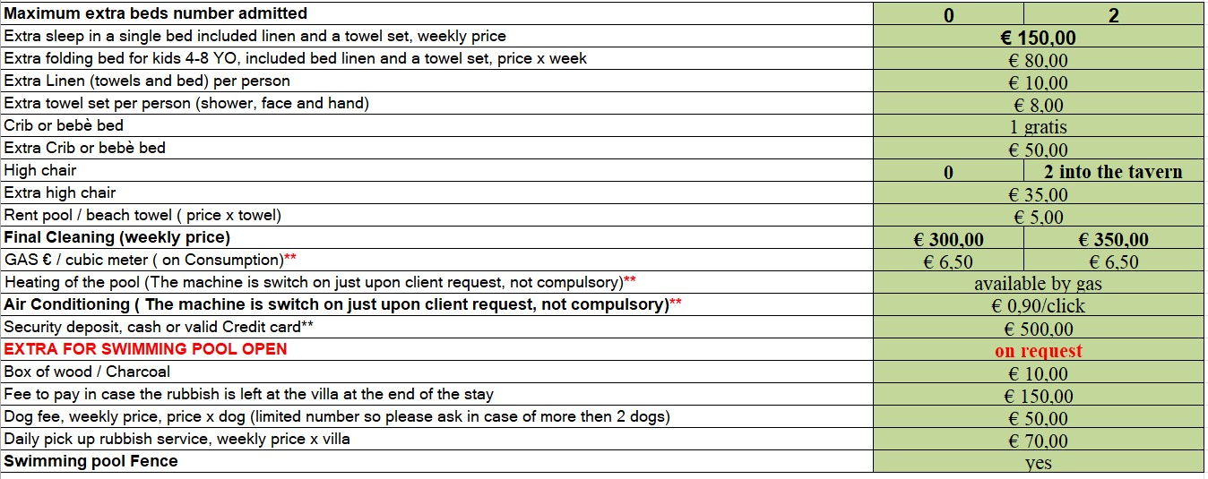

Good to know

Security deposit, EURO cash or Credit Card € 500,00 (A different amount could be asked in case of a long holiday or in other particular cases established by the property)

WATER CONSUMPTION: In case of water problems in the area a limit of water consumption considered included could be fixed. Over this limit, the consumption will be an extra cost to be paid at the end of the holiday period at the price of 5,00 €/m3. We will calculate a sufficient amount of water to cover normal consumption for a normal holiday stay. This is to avoid water wastage.

CLEANING: the final period cleaning is compulsory. In case of stays longer than 1 week the other cleanings are not compulsory but upon request.

SWIMMING POOL: swimming pool is closed in the mid-low season. It could be sometimes opened and an extra fee will be asked. Preventive just upon request. The eventual heating is always extra and switched on upon request. It’s necessary a notice at least 3 weeks prior to the arrival date to open or to heat the swimming pools. Services are not available for last-minute bookings ( less than 3 weeks before arrival).

The above prices are referred to the use of the villa as holiday house accommodation. In the case of different uses, including event use, the price will be personalized.

Distances

1 hr 47 min (127.0 km) Florence

1 hr 11 min (94.0 km) Lucca

1 hr 41 min (90.6 km) Siena

1 hr 44 min (149.6 km) Montalcino

1 hr 20 min (67.4 km) San Gimignano

55 min (64.7 km) Pisa

3 hr 14 min (289.6 km) Roma

2 hr 5 min (171.2 km) Levanto ( le Cinque Terre)