Villa Merlina

Lucca Area

Guests 8+2

2 double bedrooms and 2 double/twin bedrooms

Bathrooms 4

Panoramic view

Overview

Villa Merlina is a historic villa for rent from the 1700s near Lucca with a private swimming pool, completely restored inside with all the most modern comforts, with modern and elegant furnishings so as to make your stay an unforgettable holiday in Tuscany.

This delightful 4 bedroom Villa for rent in Tuscany has its own private park with a 9 × 4 meter and 1.5-meter deep swimming pool, olive groves and cypress trees, and a magnificent view over one of the most beautiful villages in the region. The Villa is in a strategic position to visit numerous places of interest, from the beaches of Versilia to the ancient cities of Florence, Pisa, Siena, and Lucca, as well as the many wineries in the area to taste the best wines. A few minutes from the rental villa there are supermarkets, boutiques, typical restaurants, swimming pools, spas, golf courses, tennis courts, riding stables, lakes for sport fishing, etc.

Details

Interior

A large dining room can accommodate up to 10 people and a kitchen with a delightful fireplace are on the ground floor and from these rooms, you have access to the park.

The Villa has a private swimming pool (open from April until the end of October.)

Indoor and outdoor Wi-Fi, satellite TV, pool table, ping pong, alarm system, washer, and dryer.

Details

Ground Floor: Entrance/living room, kitchen and dining room, fridge, laundry plus a double bedroom (with two single beds if necessary) and a bathroom with shower.

First Floor: Living room with sofa bed, bathroom with shower, two double bedrooms, double bedroom with two single beds if necessary, bathroom with shower and another bathroom with shower and bathtub.

Equipment

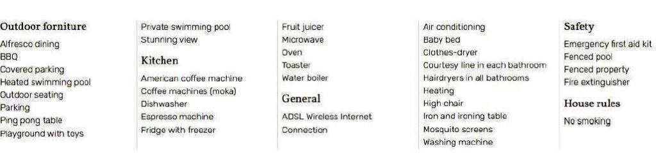

### The prices include

Internet wifi  
Bath towels  
Bed linen  
Pool towels  
Cot and highchair  
Welcome basket

### Extra cost

Final cleaning 250€ (obligatory)  
Security deposit 600€ (obligatory)  
Local taxes 0,35€ per day per person  
Utilities (electricity/heating/hot water/conditioning) € 50,00 per night  
Pool heating (on request) € 50,00 per night  
Car electric charging (on request) € 10,00 per night for car

Good to know

Check In: From 4:00 PM to 8:00 PM Check Out: By 10:00 AM

Swimming Pool: Open from 01 April - 30 October

Distances

Montecatini (nearest shops), 1.5 km, Florence (54 km), Lucca (35 km), Volterra (83 km), San Gimignano (67 km), Vinci (20 km), Pisa (58 km) , Viareggio (60 km), Forte dei Marmi (66 km), Abetone (52 km), train and bus station (3 km)