Villa Canela

Location Ibiza

Sleeps 16

Bedrooms 8: 6 doubles/twins + 2 twins

Bathrooms 7: 5 ensuite + 1 private + 1 shared

Gym

Description

Super exclusive luxury villa for rent in Ibiza, Villa Canela stands out for the elegant and modern lines of its architecture and interior. Extremely well-kept and equipped with every comfort, it will give you an unforgettable stay, immersed in nature and beauty. There is a private forest and a riding school that houses a horse.

Details

Villa Canela consists of a main body, which is spread over two floors, and a guest house. The common areas are a large living room with two openings that houses a table for 16 people, a kitchen with an island and table for 6, and a fully equipped gymnasium.

On the ground floor of the main building we have a master bedroom with en-suite bathroom and view of the pool, a second bedroom with shared bathroom overlooking the garden, a third bedroom with en-suite bathroom, private outdoor jacuzzi and view of the garden, a fourth bedroom sharing bathroom with the second room and view of the countryside.

On the second floor we have a master bedroom with four-poster bed, en-suite bathroom, private indoor jacuzzi, private terrace, private dressing room, and a second room with en-suite bathroom and private terrace with outdoor bed.

The guest house consists of a living room with table for 4 people, sofa, a room with two single beds and private outdoor bathroom and view of the countryside, and a second room with two single beds, en-suite bathroom and outdoor jacuzzi with view of the countryside.

Endowments

25000 m2 fenced

Swimming pool

Gymnasium

Outdoor children's areas

Wifi

Air conditioning

Outdoor cinema

3 outdoor bathrooms

Jacuzzi

Ecological garden

Amenities included

The prices include

Wifi

Air conditioning

General consumption

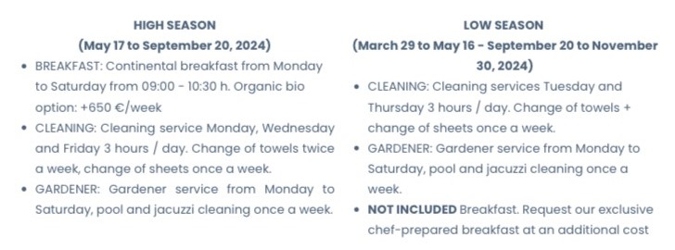

Extra cost

Security deposit

The security deposit is €5,000 paid by bank transfer and returned 72 hours after check-out.

Extras on request

Maximum two cribs for children under two years old

Breakfast. Request our exclusive chef-prepared breakfast at an additional cost

Good to know

CHECK-INS ON SATURDAYS AT 4:00 P.M. AND CHECK-OUTS AT 10:00 A.M.

MINIMUM STAY 7 DAYS.

SIGNATURE OF THE HOUSE RULES AT THE ENTRANCE.

DELIVERY OF THE PASSPORTS OF ALL THE OCCUPANTS OF THE HOUSE

-Events, meetings or parties of any kind are not allowed.

– It is not allowed to increase the capacity of the house, which is 16 people in total, including children over 2 years of age.

– The change of furniture or the placement of furniture from the interior to the exterior is not allowed.

– It is not allowed to carry out photographic reports or videos for commercialization.

– Animals or pets of any kind are not allowed.